Code coverage summary

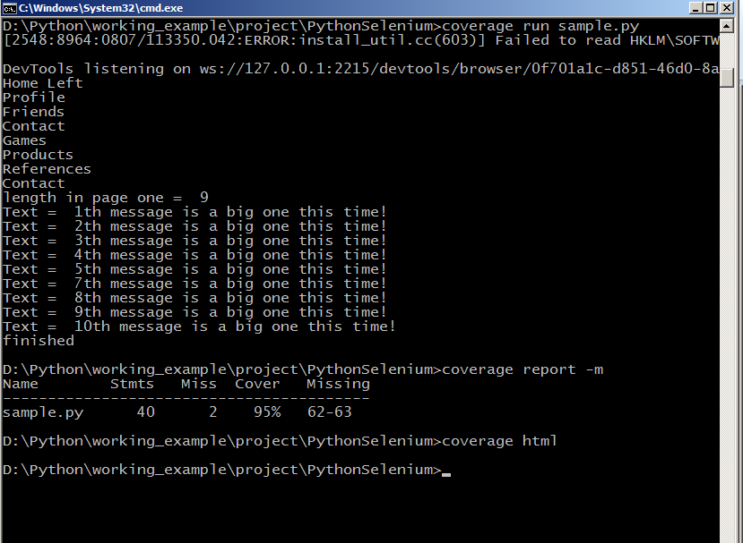

Output ------------------------------------------------------------------------------------

Home Left

Profile

Friends

Contact

Games

Products

References

Contact

length in page one = 9

Text = 1th message is a big one this time!

Text = 2th message is a big one this time!

Text = 3th message is a big one this time!

Text = 4th message is a big one this time!

Text = 5th message is a big one this time!

Text = 7th message is a big one this time!

Text = 8th message is a big one this time!

Text = 9th message is a big one this time!

Text = 10th message is a big one this time!

finished